**Lab No 13**

**Name : Muhammad Faizan Reg. No. : 21-NTU-CS-1258**

**(Q1)**

#include<iostream>

#include<cstring>

using namespace std;

class car

{

char brand[20];

int model;

int traveledmiles;

char color[20];

public:

car(){

strcpy(brand,"Honda");

model=2018;

traveledmiles=25000;

strcpy(color,"white");

}

void display()

{

cout<<"Brand is "<<brand<<endl;

cout<<"Model is "<<model<<endl;

cout<<"Total miles traveled is "<<traveledmiles<<endl;

cout<<"Color is "<<color<<endl;

}

};

int main()

{

car obj;

obj.display();

}

**Output**

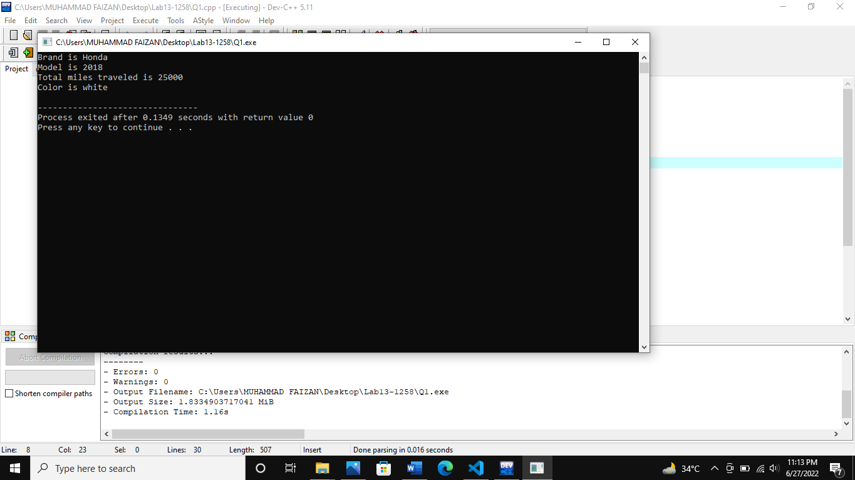

**(Q2)**

#include<iostream>

#include<cstring>

using namespace std;

class house

{

int length;

int width;

int rooms;

int bathrooms;

char furnished[10];

public:

house()

{

length=100;

width=100;

rooms=5;

bathrooms=6;

strcpy(furnished,"Yes");

}

house(int a,int b,int c,int d,char *e)

{

length=a;

width=b;

rooms=c;

bathrooms=d;

strcpy(furnished, e);

}

void display()

{

cout<<"The length of house in feet is "<<length<<endl;

cout<<"The width of house in feet is "<<width<<endl;

cout<<"The No. of rooms in house is "<<rooms<<endl;

cout<<"The No. of bathrooms in house is "<<bathrooms<<endl;

cout<<"Furnished House "<<furnished<<endl;

cout<<endl;

cout<<"=========================================="<<endl;

}

};

int main()

{

house h;

house h1(250,260,7,6,"Yes");

h.display();

h1.display();

}

**Output**

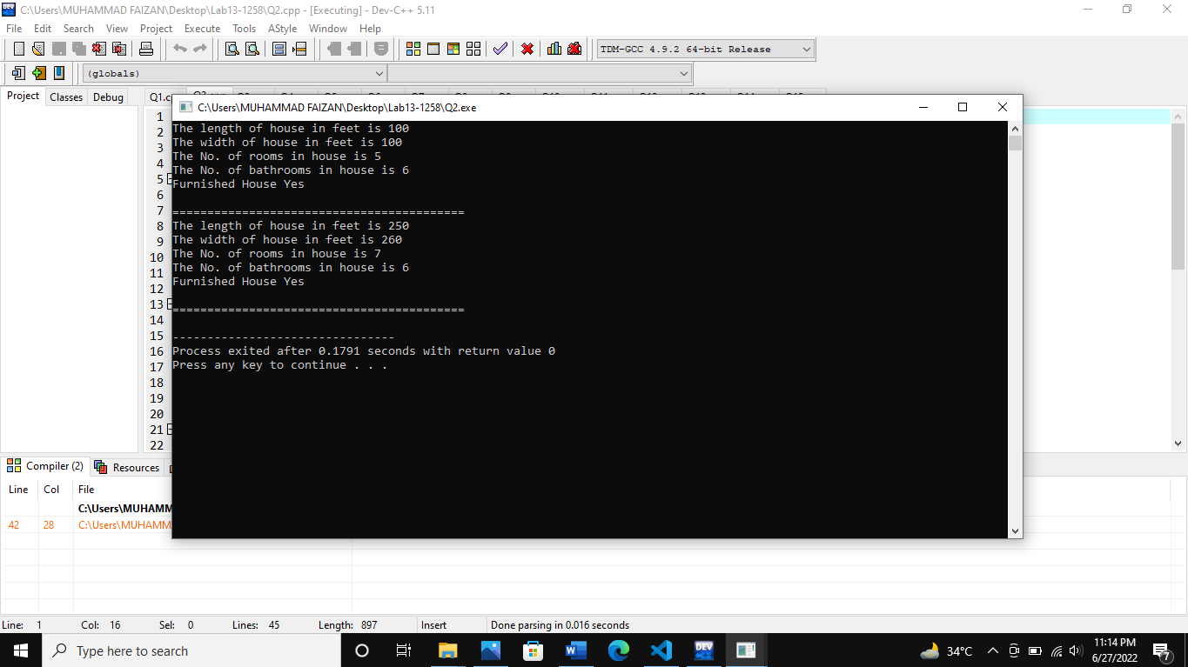

**(Q3)**

#include<iostream>

#include<cstring>

using namespace std;

class house

{

int length;

int width;

int rooms;

int bathrooms;

char furnished[10];

public:

void len(int a)

{

length=a;

}

void wid(int b)

{

width=b;

}

void room(int c)

{

rooms=c;

}

void bathroom(int d)

{

bathrooms=d;

}

void furnish(char *e)

{

strcpy(furnished, e);

}

house()

{

length=100;

width=100;

rooms=5;

bathrooms=6;

strcpy(furnished,"Yes");

}

house(int a,int b,int c,int d,char *e)

{

length=a;

width=b;

rooms=c;

bathrooms=d;

strcpy(furnished, e);

}

void display()

{

cout<<"The length of house in feet is "<<length<<endl;

cout<<"The width of house in feet is "<<width<<endl;

cout<<"The No. of rooms in house is "<<rooms<<endl;

cout<<"The No. of bathrooms in house is "<<bathrooms<<endl;

cout<<"Furnished House "<<furnished<<endl;

cout<<endl;

cout<<"=========================================="<<endl;

}

};

int main()

{

house *a;

a=new house;

a->len(600);

a->wid(600);

a->room(5);

a->bathroom(6);

a->furnish("No");

a->display();

}

**Output**

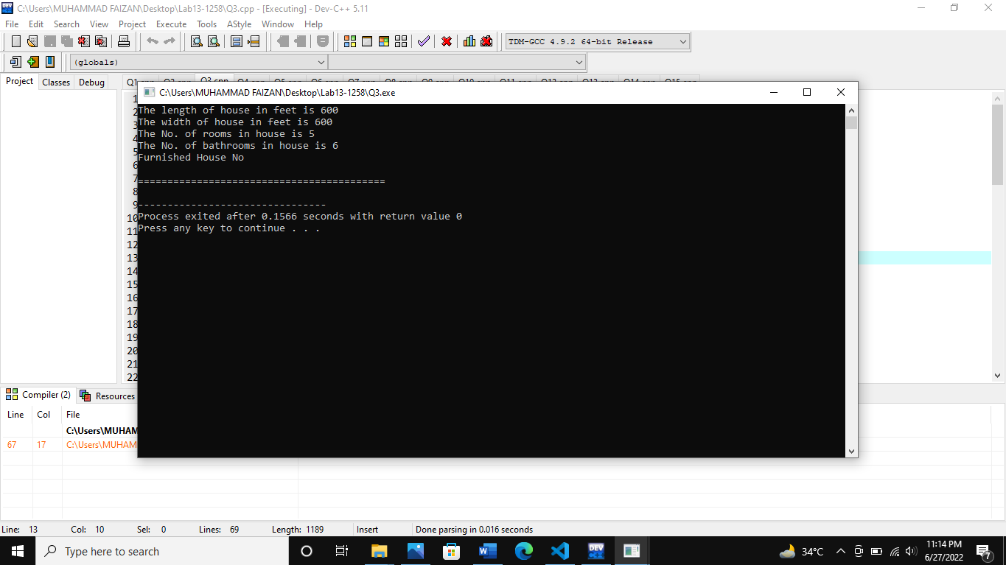

**(Q4)**

#include<iostream>

#include<cstring>

#include<iomanip>

using namespace std;

class employee

{

int EmployeeID;

char First_Name[30];

char Last_Name[30];

char Designation[30];

long long Phone_Number;

public:

employee(){

EmployeeID = 0;

}

employee(int a, char *b, char *c, char *d, long long f){

EmployeeID = a;

strcpy(First_Name, b);

strcpy(Last_Name, c);

strcpy(Designation, d);

Phone_Number = f;

}

void set(int e, char *g, char *h, char *i, long long j)

{

EmployeeID =e;

strcpy(First_Name, g);

strcpy(Last_Name, h);

strcpy(Designation, i);

Phone_Number = j;

}

void show()

{

cout<<left<<setw(18)<<EmployeeID;

cout<<left<<setw(18)<<First_Name;

cout<<left<<setw(18)<<Last_Name;

cout<<left<<setw(18)<<Designation;

cout<<left<<setw(18)<<Phone_Number<<endl;

}

char* GetName(void)

{

return First_Name;

}

int GetID(void)

{

return EmployeeID;

}

};

void search(employee a[])

{

char b[30];

int count=0;

cout<<"Enter the first name of employee you want to see record : ";

cin>>b;

cout<<endl<<"The record of employee : "<<b<<endl<<endl;

cout<<left<<setw(18)<<"ID"<<setw(18)<<"First Name"<<setw(18)<<"Last Name"<<setw(18)<<"Designation"<<setw(18)<<"Phone Number"<<endl<<endl;

for(int i=0; i<10; i++)

{

if(strcmp(a[i].GetName(), b)==0)

{

a[i].show();

count++;

}

}

if(count==0)

cout<<"NO Exist!";

}

int main()

{

employee ep[10];

int a;

char n1[30], n2[30], d[30];

long long e;

for(int i=0; i<10; i++)

{

cout<<"Enter Employee ID : ";

cin>>a;

cout<<"Enter Employee First Name : ";

cin>>n1;

cout<<"Enter Employee Last Name : ";

cin>>n2;

cout<<"Enter Employee Designation : ";

cin>>d;

cout<<"Enter Employee Phone Number: ";

cin>>e;

ep[i].set(a, n1, n2, d, e);

cout<<"\n------------------------------------------------\n"<<endl;

}

cout<<left<<setw(18)<<"ID"<<setw(18)<<"First Name"<<setw(18)<<"Last Name"<<setw(18)<<"Designation"<<setw(18)<<"Phone Number"<<endl;

for(int i=0; i<10; i++)

{

ep[i].show();

}

cout<<"\n________________________________________________________________________\n"<<endl;

search(ep);

}

**Output**

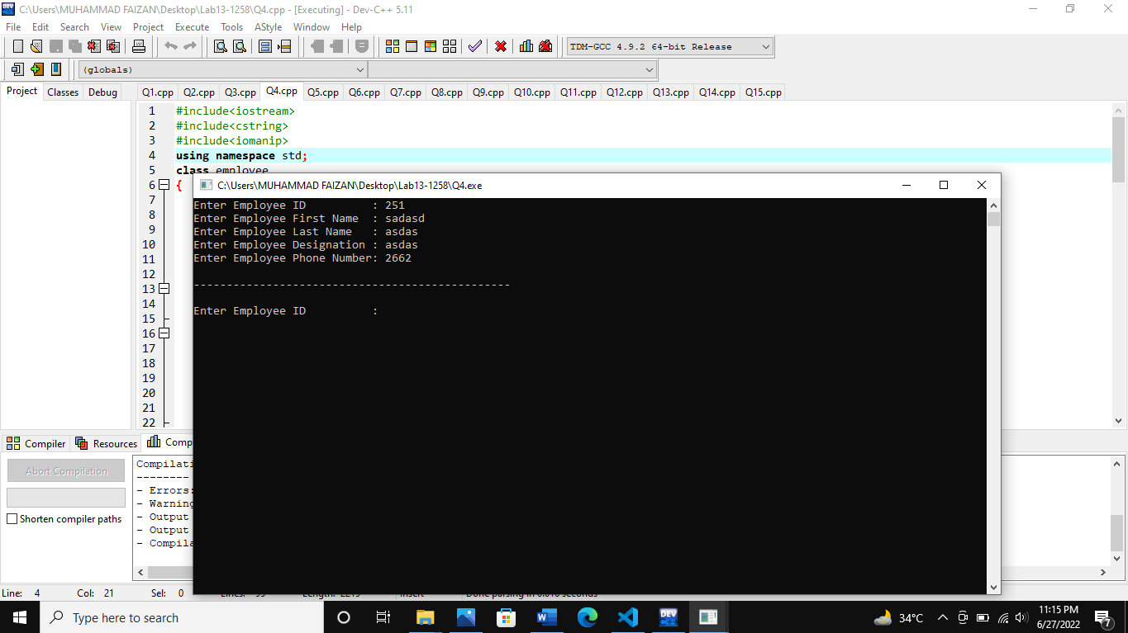

**(Q5)**

#include<iostream>

#include<fstream>

using namespace std;

int main()

{

ifstream file1("Name.txt");

if(!file1)

{

cout<<"Not avalible"<<endl;

}

char a[100];

while(file1>>a)

{

cout<<a<<" ";

}

}

**Output**

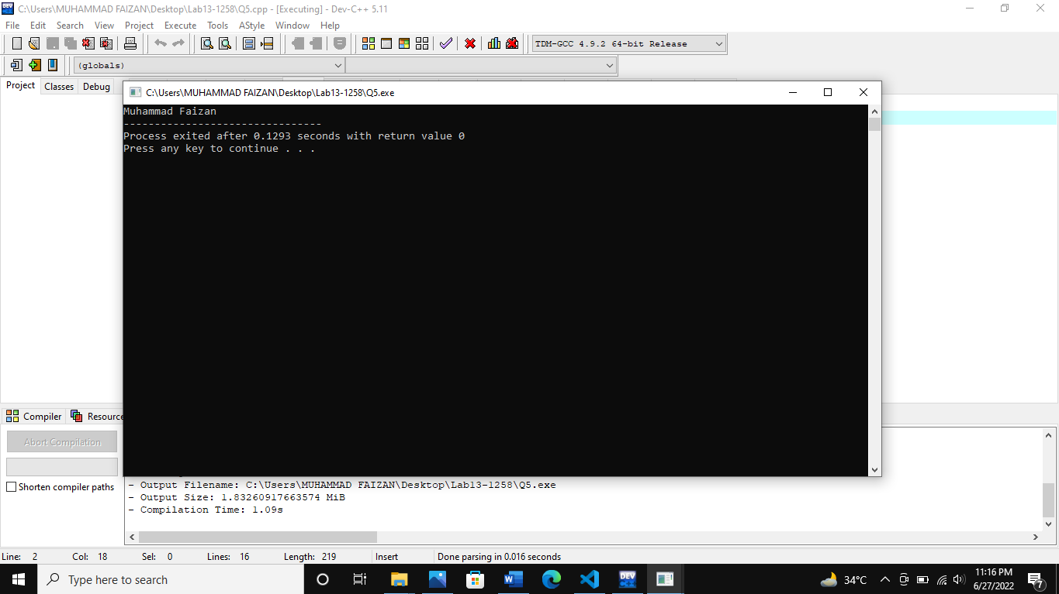

**(Q6)**

#include<iostream>

#include<fstream>

using namespace std;

int main()

{

ifstream file1("file.txt");

if(!file1)

{

cout<<"Not avalible"<<endl;

}

char a[100];

while(file1>>a)

{

cout<<a<<" ";

}

}

**Output**

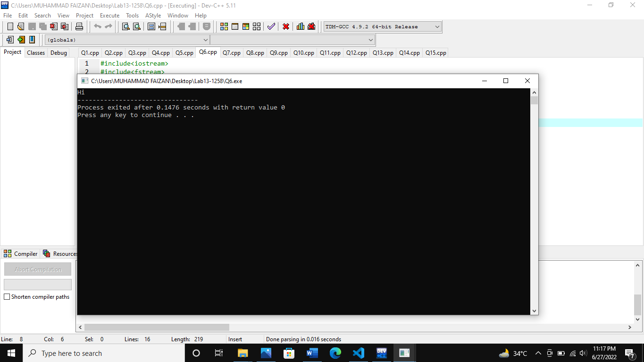

**(Q7)**

#include<iostream>

#include<fstream>

using namespace std;

int main()

{

ifstream file1("Q7.cpp");

if(!file1)

{

cout<<"Not avalible"<<endl;

}

char a[100];

while(file1>>a)

{

cout<<a<<" ";

}

}

**Output**

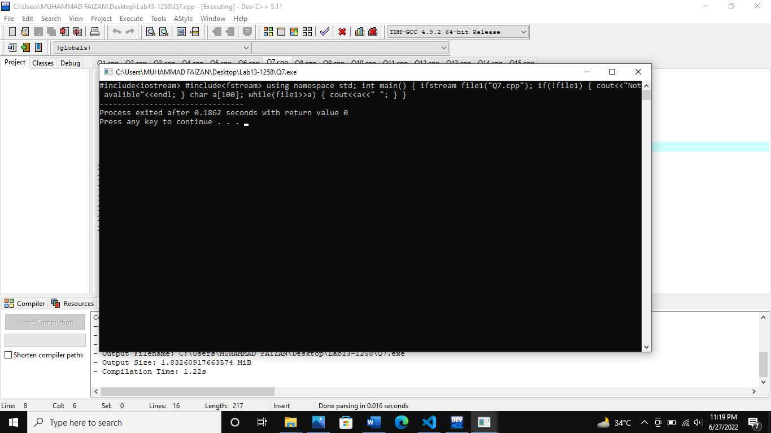

**(Q8)**

#include<iostream>

#include<fstream>

using namespace std;

int main()

{

ifstream file1("Question 8.cpp");

if(!file1)

cout<<"Not Open"<<endl;

char arry[100];

char a[400];

int count=0;

int i=0;

while(file1>>arry)

{

for(int y=0; arry[y]!='\0'; i++, y++)

{

a[i] = arry[y];

count++;

}

}

for(int i=(count-1); i>=0; i--)

{

cout<<a[i];

}

}

**Output**

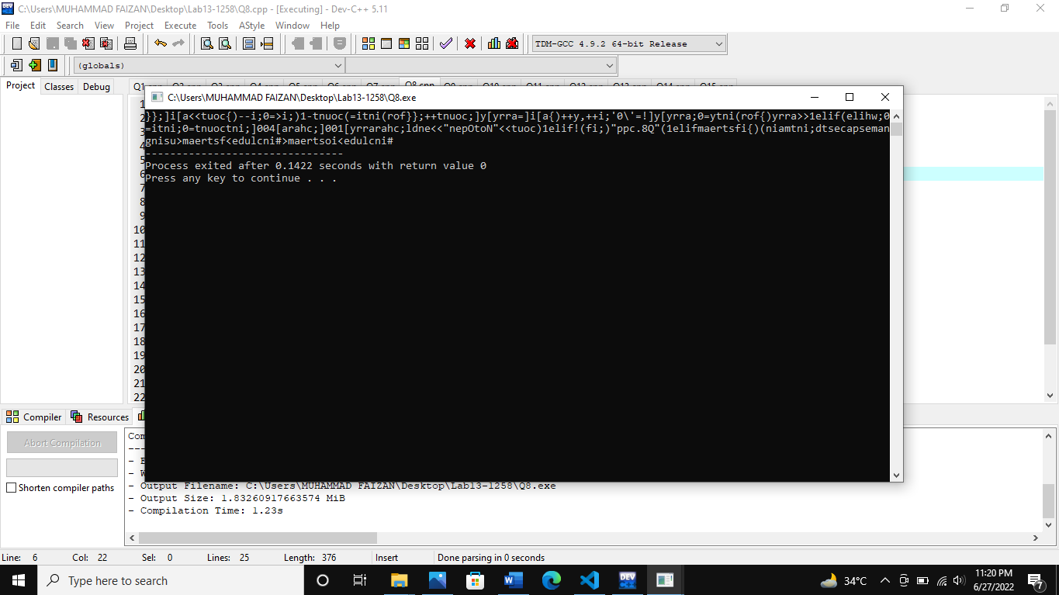

**(Q9)**

#include<iostream>

#include<fstream>

using namespace std;

int main()

{

ifstream file1("file1.txt");

if(!file1)

{

cout<<"Not avalible"<<endl;

}

char a[100];

char b[100];

while(file1>>a)

{

cout<<a<<" ";

}

file1.seekg(ios::beg);

while(file1>>b)

{

cout<<b<<endl;

}

}

**Output**

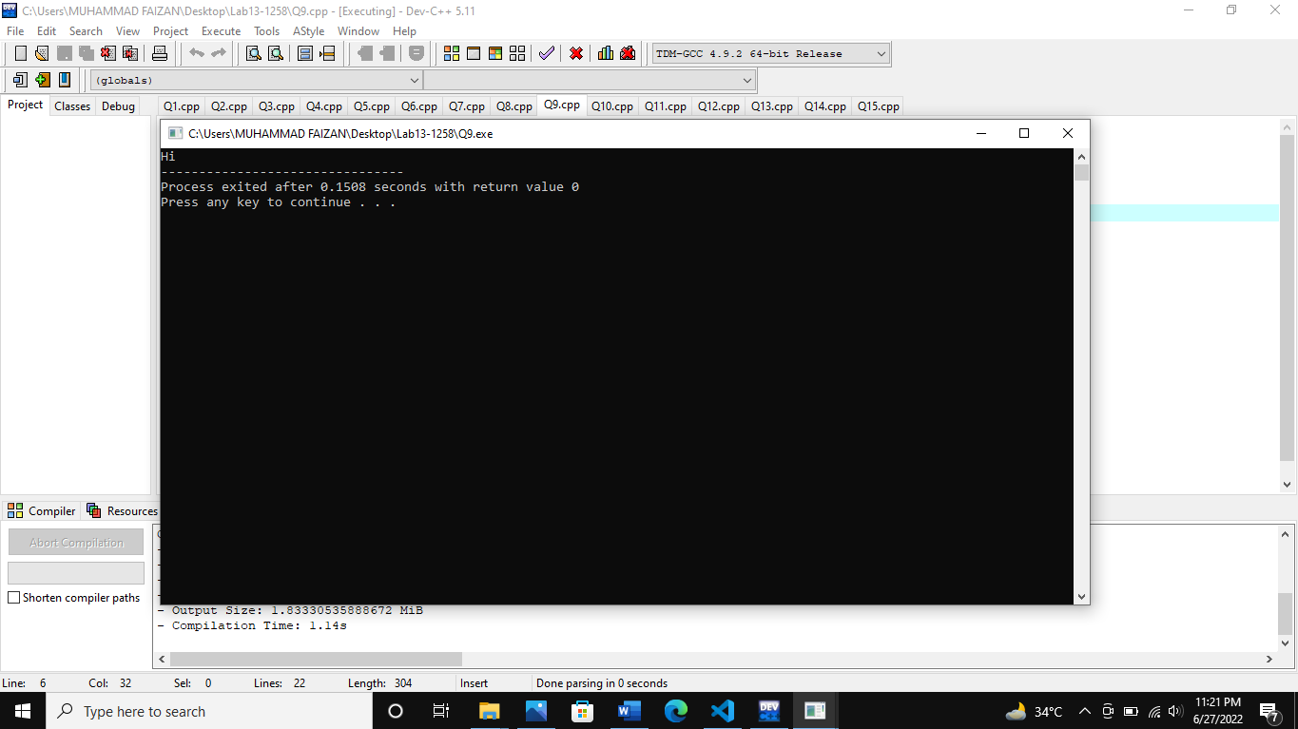

**(Q10)**

#include<iostream>

#include<fstream>

using namespace std;

int main()

{

ifstream file1("10.1.txt");

ifstream file2("10.2.txt");

if(!file1)

{

cout<<"Not avalible"<<endl;

}

if(!file2)

{

cout<<"Not avalible"<<endl;

}

char a[100] , b[100];

while(file1>>a)

{

cout<<a;

}

while(file2>>b)

{

cout<<a;

}

}

**Output**

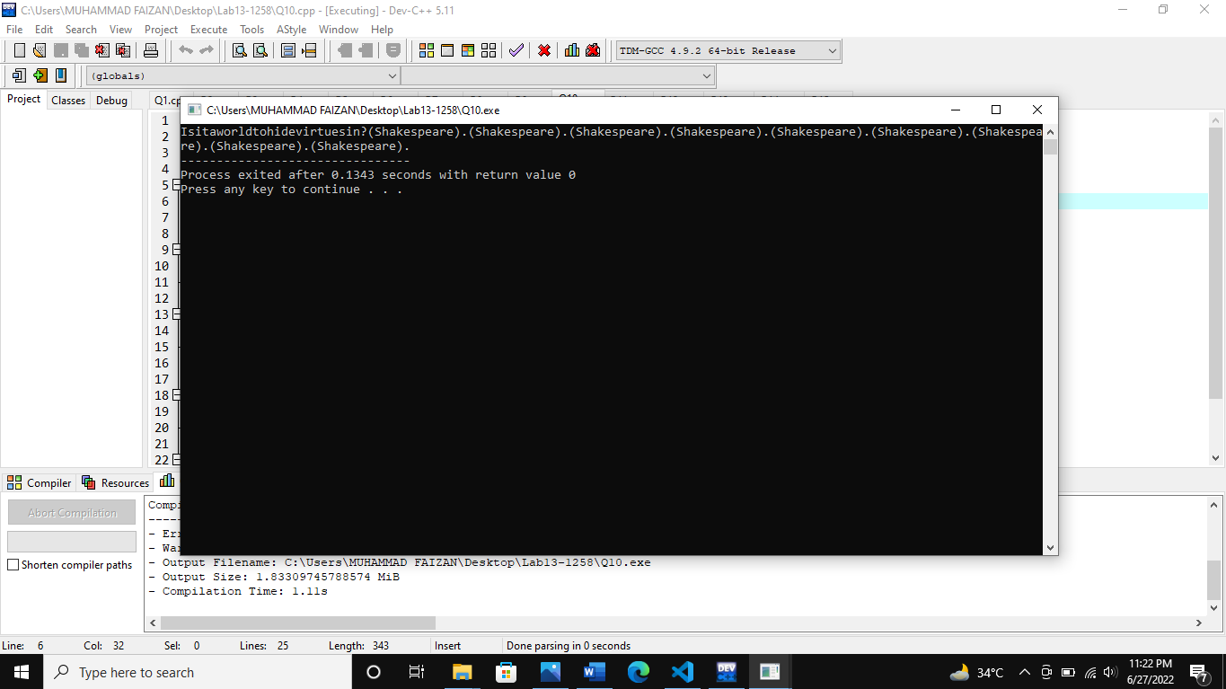

**(Q11)**

#include<iostream>

#include<fstream>

#include<iomanip>

using namespace std;

int main()

{

ifstream file1("Q11.txt");

if(!file1)

cout<<"Not Open";

string first_name, last_name, phone_number, email;

int i=0;

while(file1>>first_name>>last_name>>phone_number>>email)

{

cout<<left<<setw(18)<<first_name;

cout<<left<<setw(18)<<last_name;

cout<<left<<setw(18)<<phone_number;

cout<<left<<setw(18)<<email;

cout<<endl;

}

}

**Output**

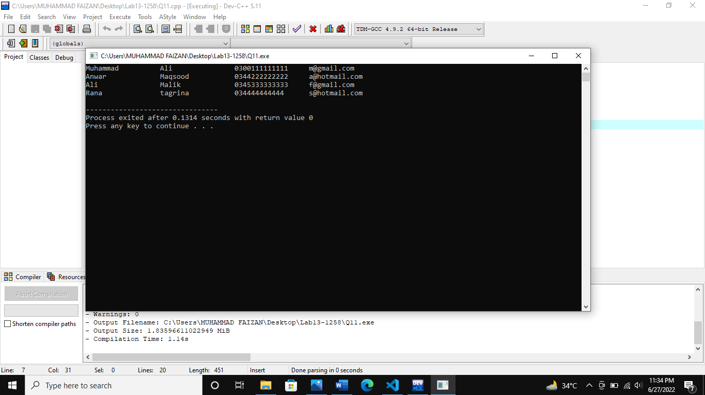

**(Q12)**

#include<iostream>

#include<fstream>

#include<iomanip>

#include<cstring>

using namespace std;

void search(ifstream &fil)

{

string x;

cout<<"Enter a first name : ";

cin>>x;

string first_name, last_name, phone_number, email;

while(fil>>first_name>>last_name>>phone_number>>email)

{

if(x==first_name)

{ cout<<left<<setw(18)<<first_name;

cout<<left<<setw(18)<<last_name;

cout<<left<<setw(18)<<phone_number;

cout<<left<<setw(18)<<email;

cout<<endl;

}

}

}

int main()

{

ifstream file1("Q11.txt");

if(!file1)

cout<<"Not Open"<<endl;

search(file1);

}

**Output**

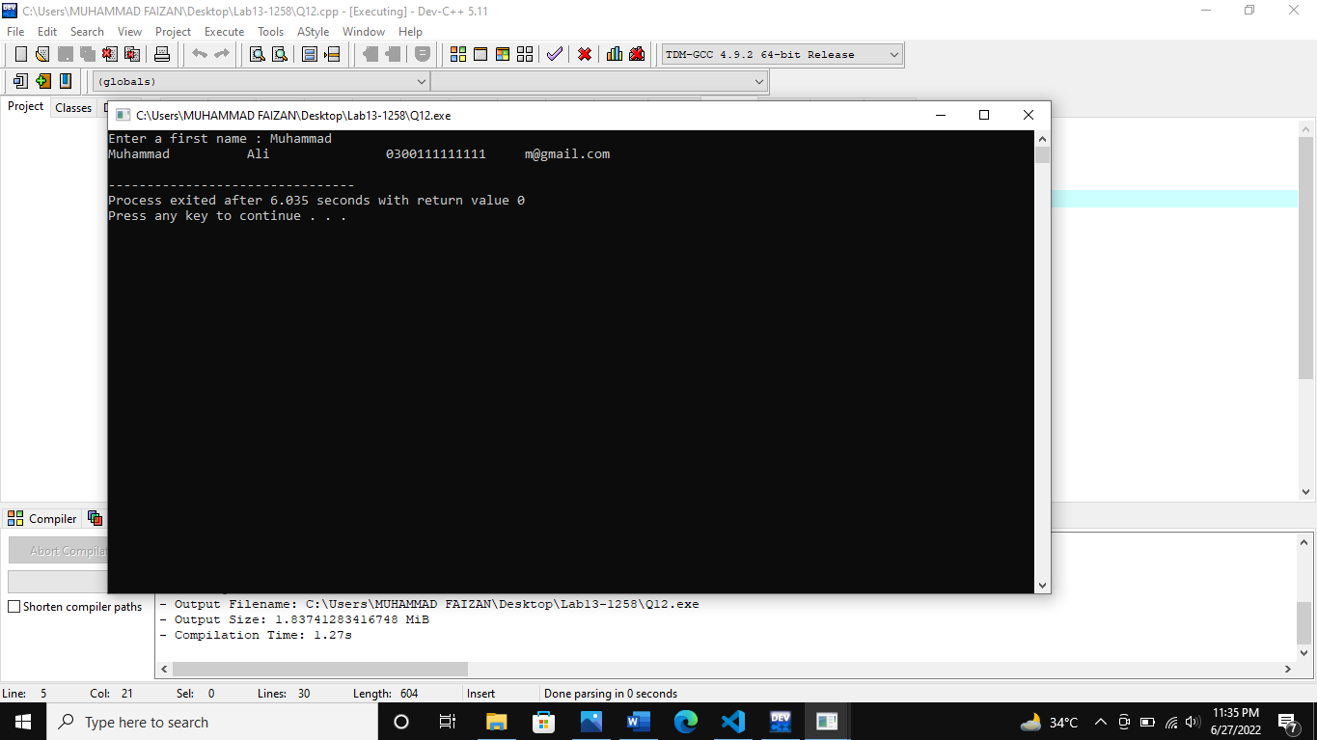

**(Q13)**

#include<iostream>

#include<fstream>

using namespace std;

int main()

{

ifstream file1("Q13.txt");

if(!file1)

cout<<"Not Open"<<endl;

string a;

int count=0;

while(file1>>a)

{

if(a=="file")

{

count++;

}

}

cout<<"The word \"file\" is appeared in file : "<<count<<" times.";

}

**Output**

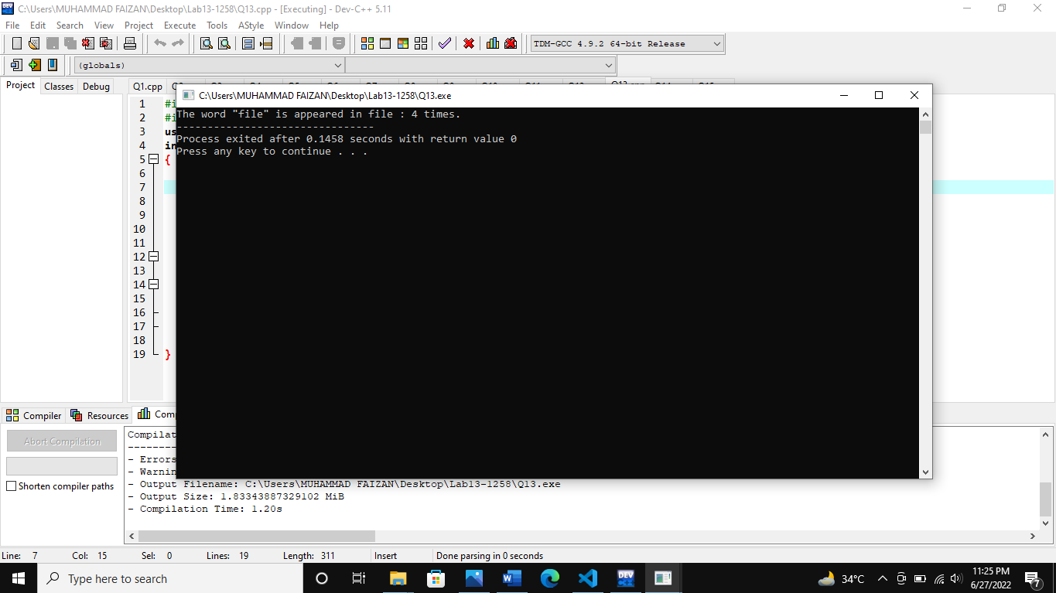

**(Q14)**

#include<iostream>

#include<fstream>

using namespace std;

int main()

{

ifstream file1("Q14.txt");

if(!file1)

cout<<"Not Open"<<endl;

string a;

int counta=0, counthe=0;

while(file1>>a)

{

if(a=="a")

{

counta++;

}

if(a=="the")

{

counthe++;

}

}

cout<<"The article \"a\" appeared in file "<<counta<<" times."<<endl<<endl;

cout<<"The article \"the\" appeared in file "<<counthe<<" times."<<endl;

}

**Output**

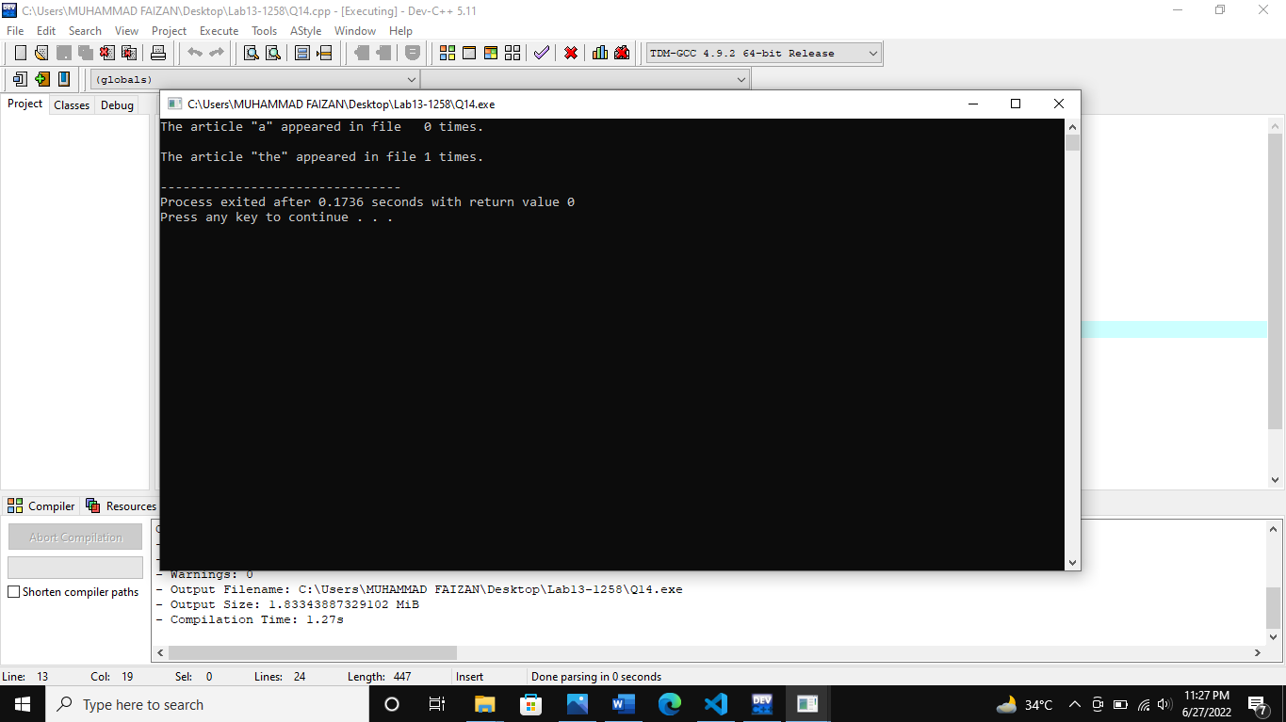

**(Q15)**

#include<iostream>

#include<fstream>

#include<iomanip>

using namespace std;

int main()

{

ifstream file1("Q11.txt");

if(!file1)

cout<<"Not Open";

string b, first_name, last_name, phone_number, email;

int i=0;

while(file1>>first_name>>last_name>>phone_number>>email)

{

b = first_name[0];

if(b=="M")

{

cout<<left<<setw(18)<<first_name;

cout<<left<<setw(18)<<last_name;

cout<<left<<setw(18)<<phone_number;

cout<<left<<setw(18)<<email;

cout<<endl;

}

}

}

**Output**

